🧠 SPLUNK FORWARDER SETUP & WINDOWS 10 ENDPOINT LOG INGESTION

(Windows 10 → Ubuntu Splunk Enterprise)
End-to-End | Theory → Pre-Checks → Setup → Splunk-Side Config → Validation
Platform: Splunk
Scope: Single Windows 10 endpoint → Ubuntu Splunk server
Goal: Perfect log generation, clean ingestion, trustworthy investigation data

PART 1 — CORE THEORY (MINIMUM, MUST-KNOW)

1️⃣ What Splunk Is (in this architecture)
- Ubuntu Server runs Splunk Enterprise
  - Receives logs
  - Indexes logs
  - Makes logs searchable
- Windows 10 is only a log source
⚠️ Splunk does NOT pull logs from Windows by default.

2️⃣ What the Splunk Universal Forwarder Is
The Splunk Universal Forwarder (UF) is a lightweight agent that:
- Reads logs locally on Windows
- Sends them to Splunk over the network
- Does NO indexing
- Does NO searching
Forwarder = log shipper
Splunk Enterprise = analysis engine

3️⃣ Why Windows Needs a Forwarder
- Windows logs live inside Event Viewer
- SOC environments use agent-based collection
- Logs must be pushed, not pulled
Architecture:
Windows 10
└─ Splunk Universal Forwarder
└─ Ubuntu Splunk Enterprise

4️⃣ Logs We Ingest (INTENTIONALLY LIMITED)
✅ Windows Security log ONLY
Why:
- Authentication (logon / logoff)
- Failed & successful logons
- User and IP evidence
- SOC-relevant behavior
🚫 Sysmon
🚫 PowerShell logging
🚫 Script block logging
🚫 Registry auditing
🚫 Object access everywhere
➡️ These are not missing — they are intentionally excluded (explained later).

PART 2 — WINDOWS PRE-CHECKS

(FOR PERFECT LOG GENERATION — BEFORE FORWARDER INSTALL)
🔒 Golden rule: Fix log generation first.
Splunk can only ingest what Windows actually generates.

🔴 1️⃣ Windows Event Log Service
GUI
- Win + R → services.msc
- Find Windows Event Log
Must be
- Status: Running
- Startup type: Automatic
If this fails → nothing else matters.
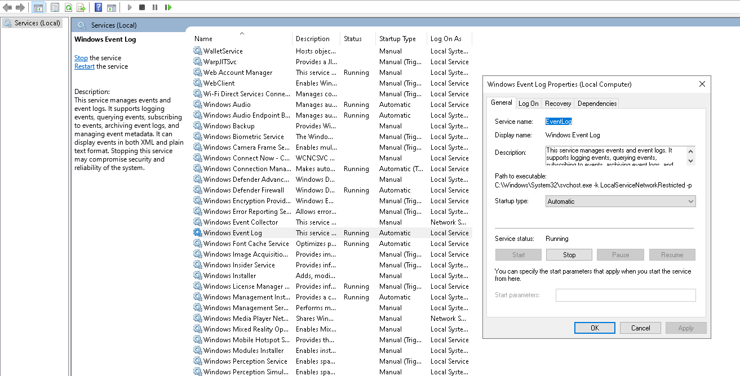

🔴 2️⃣ Security Log Must Exist & Update
GUI
- Open Event Viewer
- Go to:
- Windows Logs → Security
- Refresh
Confirm
- Events already exist
- New events appear when you:
  - Lock / unlock the screen
  - Log in / log out
If Event Viewer is empty → Splunk will also be empty.

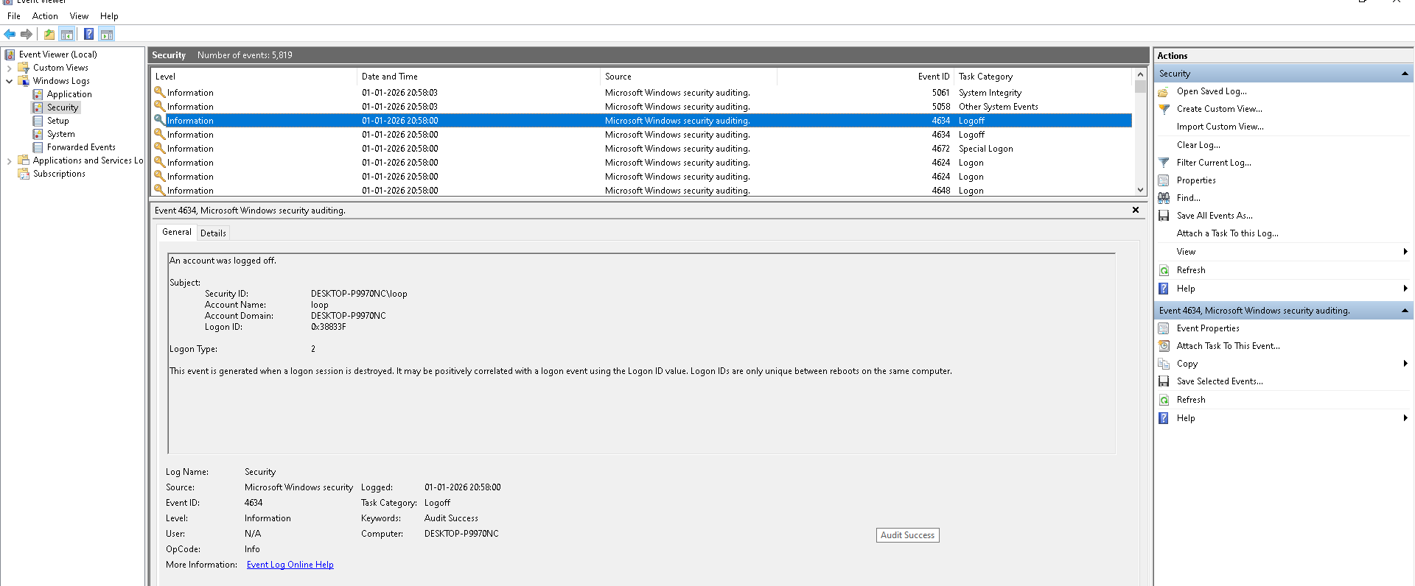

Got it. I’ll rewrite and expand this properly, turning it into a SOC-grade, step-by-step guide you can directly use in your lab doc.
No fluff, no shortcuts, no misleading simplifications.

🔴 3️⃣ Advanced Audit Policy — Authentication (CRITICAL)
This phase answers the most important SOC question:
Did Windows reliably record every successful and failed authentication attempt?
If this is wrong, everything built on top of it is unreliable.

🎯 Objective
Ensure Windows logs:
- Successful logons
- Failed logons
- Credential validation attempts
Without this:
- Failed logons are invisible
- Brute-force and password spraying cannot be detected
- Windows appears “quiet” even when attacks occur

📍 GUI Navigation (Exact Path)
- Press Win + R
- Type:
- secpol.msc
- Press Enter → Local Security Policy opens
- Navigate to:
- Security Settings
- → Advanced Audit Policy Configuration
- → Audit Policies
⚠️ Important
Do NOT configure Basic Audit Policy.
Advanced Audit Policy overrides it and is SOC-correct.

🔐 3.1 Account Logon — Credential Validation
This controls password validation events.
Path:
Audit Policies
→ Account Logon
Enable:

✅ Audit Credential Validation
- ✔ Success
- ✔ Failure
Why this matters:
- Records failed authentication attempts
- Generates events like:
  - 4625 (failed logon)
  - 4776 (credential validation)
Without this:
- Brute-force attempts may not appear at all
- Attackers can guess passwords silently

🔑 3.2 Logon / Logoff — Session Creation & Destruction
This controls user session activity on the endpoint.
Path:
Audit Policies
→ Logon/Logoff
Enable all of the following:

✅ Audit Logon
- ✔ Success
- ✔ Failure
Purpose:
- Records session creation
- Generates:
  - 4624 (successful logon)
  - 4625 (failed logon at endpoint)

✅ Audit Logoff
- ✔ Success
Purpose:
- Records session termination
- Generates:
  - 4634 (logoff)
Why SOCs care:
- Needed for timeline reconstruction
- Helps differentiate normal vs abnormal session endings

✅ Audit Special Logon
- ✔ Success
Purpose:
- Identifies privileged sessions
- Generates:
  - 4672 (admin / special privileges assigned)
Without this:
- You lose visibility into who logged in with elevated rights

🧠 Outcome of Step 3
After this step, Windows must record:
- Successful logons
- Failed logons
- Privileged logons
- Logoff events
If any of these are missing, authentication visibility is broken.

🔴 4️⃣ Privilege Use — Post-Logon Evidence
This phase answers:
What did the user do after logging in?

🎯 Objective
Detect privilege abuse after access, not just access itself.

📍 GUI Navigation
Advanced Audit Policy Configuration
→ Audit Policies
→ Privilege Use

🔓 Enable Sensitive Privilege Use

✅ Audit Sensitive Privilege Use
- ✔ Success
- ✔ Failure
Why this matters:
- Logs use of powerful privileges (e.g., debug, impersonation)
- Helps identify post-exploitation activity
- Shows attacker behavior after initial compromise
SOC value: HIGH

🔴 5️⃣ Process Creation — Execution Visibility (Without Sysmon)
This phase answers:
What executed immediately after authentication?
It links:
Logon → Process Execution

🎯 Objective
Track process execution without using Sysmon (baseline Windows only).

📍 GUI Navigation
Advanced Audit Policy Configuration
→ Audit Policies
→ Detailed Tracking

🖥️ Enable Process Creation

✅ Audit Process Creation
- ✔ Success
What this generates:
- 4688 (new process created)
- Parent → child process relationships (basic)
Why this matters:
- Shows commands launched after logon
- Bridges authentication events to attacker behavior
- Teaches SOC reasoning before advanced tooling
⚠️ This is not Sysmon, but it is enough to learn:
- Correlation
- Timelines
- Analyst thinking

🔁 Mandatory Reboot (Do Not Skip)
After configuring Steps 3–5:
👉 Reboot the system
Reason:
- Advanced audit policies are cached
- Some settings do not apply cleanly without reboot
- Skipping this leads to inconsistent logs

✅ Final Verification Checklist
After reboot, confirm in Event Viewer → Security:
- 4625 → Failed logon
- 4624 → Successful logon
- 4672 → Privileged logon
- 4634 → Logoff
- 4688 → Process creation
If any one is missing, the configuration is invalid.

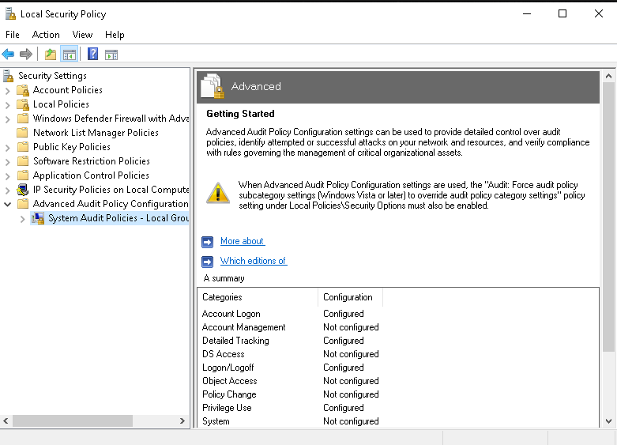

🔴 6️⃣ Security Log Size & Retention
GUI
- Event Viewer → Right-click Security
- Properties
Set:
- Log size: ≥ 200 MB
- Retention: Overwrite events as needed (lab)
Small logs = missing early attack stages.

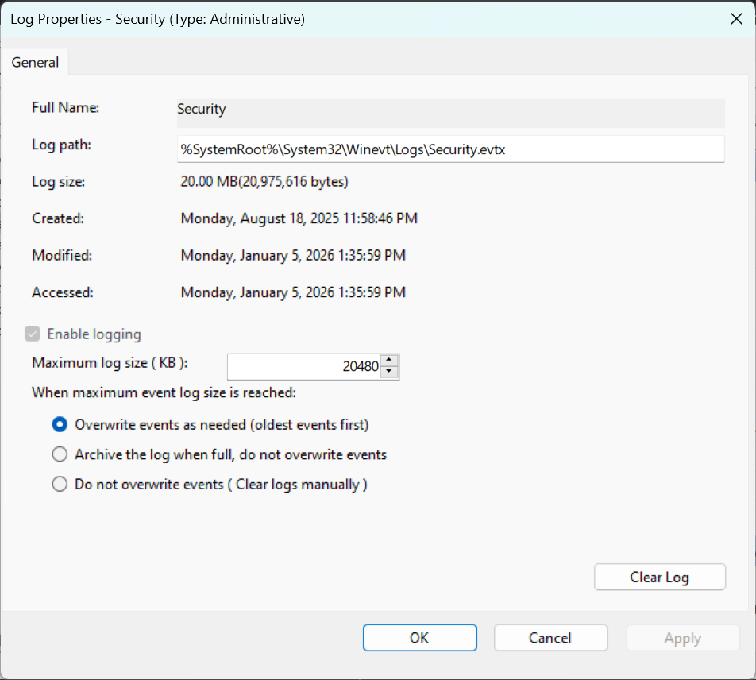

🔴 7️⃣ Time & Time Zone
GUI
- Right-click clock → Date & Time settings
Ensure:
- Correct time zone
- Correct time
- Automatic time sync ON
Wrong time = broken timelines.

🔴 8️⃣ Firewall (Outbound)
GUI
- Windows Defender Firewall
- Advanced settings → Outbound Rules
Ensure:
- No rule blocks TCP 9997
- Optional explicit allow rule

🔴 9️⃣ Permissions
Ensure:
- You are Local Administrator
- Forwarder will run as Local System
Local System can read Security logs.

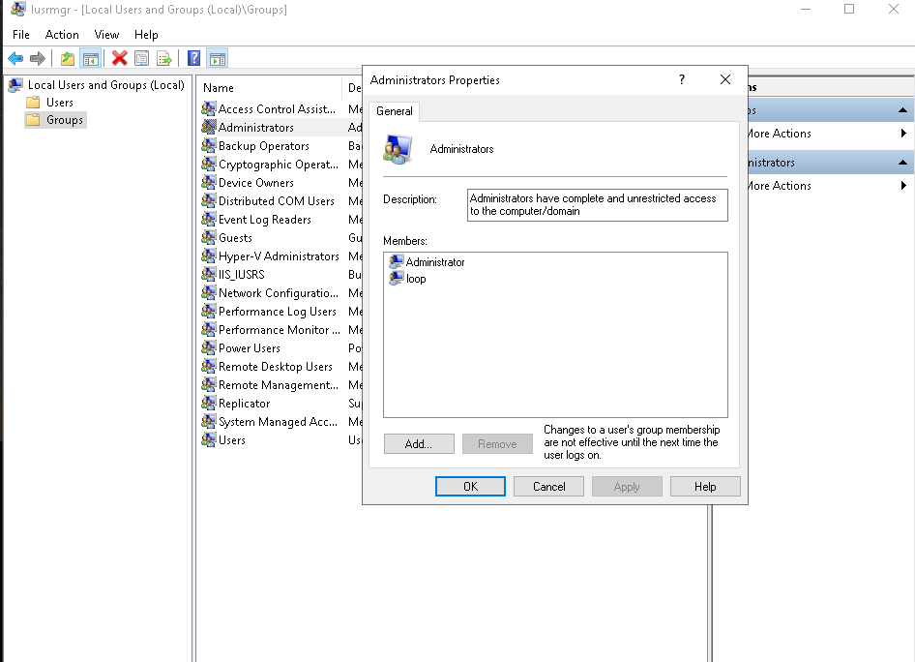

✅ WINDOWS PRE-CHECK CHECKLIST (ALL MUST BE YES)
☑ Windows Event Log running
☑ Security log populated & updating
☑ Audit Logon enabled (Success + Failure)
☑ Audit Account Logon enabled
☑ Privilege Use auditing enabled
☑ Process Creation auditing enabled
☑ Security log size increased
☑ Correct time & timezone
☑ Firewall allows outbound 9997
☑ Admin access confirmed

PART 3 — SPLUNK-SIDE PREPARATION (BEFORE DATA ARRIVES)

🔴 STEP 1 — CREATE A DEDICATED WINDOWS INDEX (MANDATORY)
Why
- Prevents Linux + Windows log mixing
- Improves performance
- Mirrors real SOC design
GUI
- Splunk Web → Settings → Indexes
- Click New Index
Configure:
- Index name: windows
- Leave defaults
Save.
🚫 Using main index = beginner mistake.

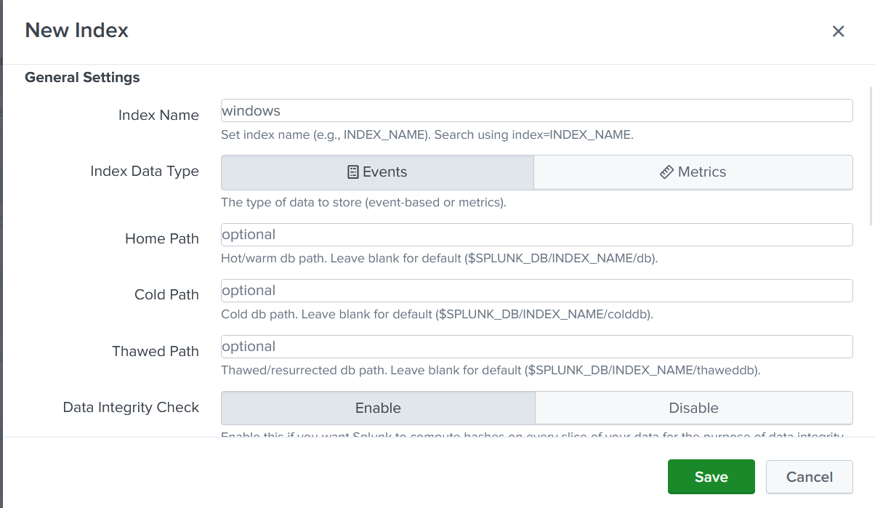

🔴 STEP 2 — ENABLE RECEIVING ON SPLUNK
GUI
- Settings → Forwarding and Receiving
- Configure receiving
- Ensure port 9997 exists and is enabled
Without this, forwarder sends logs into a black hole.
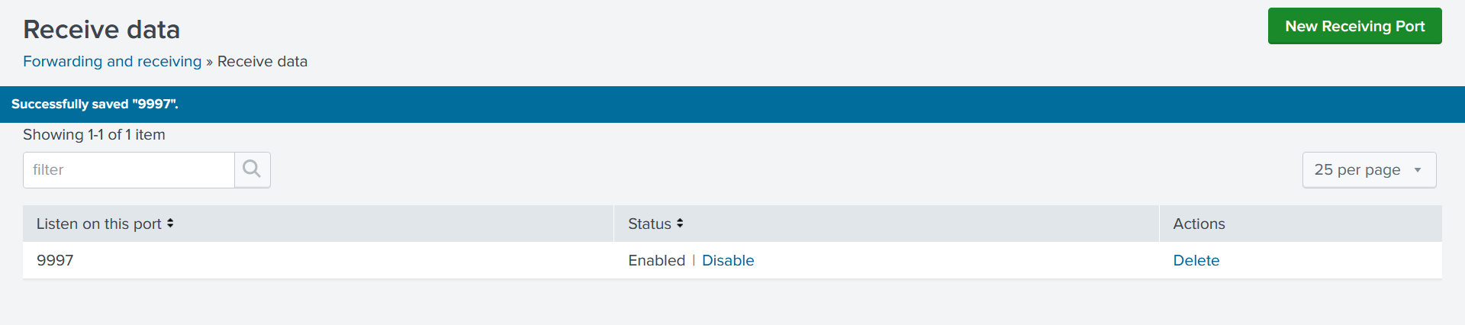

PART 4 — SPLUNK FORWARDER INSTALLATION (WINDOWS GUI)

🔴 STEP 3 — INSTALL SPLUNK UNIVERSAL FORWARDER
- Download Splunk Universal Forwarder (Windows 64-bit MSI)
- Run installer as Administrator
During install:
- Accept license
- Run as Local System
- Start on boot
- Skip Deployment Server
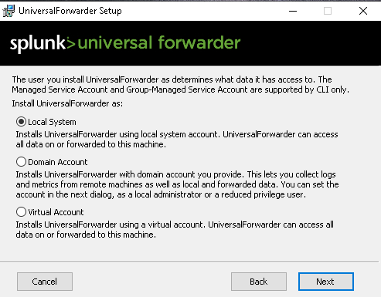

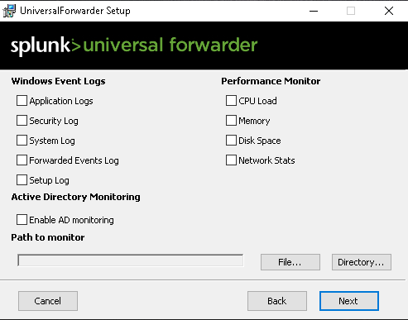
👉 Click Next with everything empty.

Set Username And Password

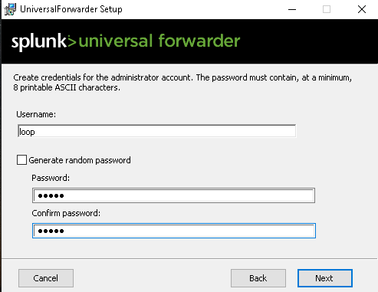

Receiving Indexer
- IP: <ubuntu-ip>
- Port: 9997

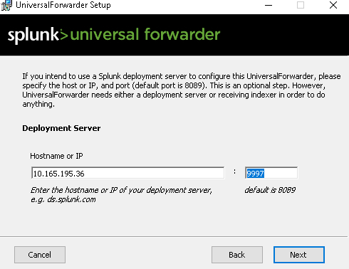
Finish install.

🔴 STEP 4 — VERIFY FORWARDER SERVICE
GUI
- services.msc
- SplunkForwarder
  - Status: Running
  - Startup: Automatic
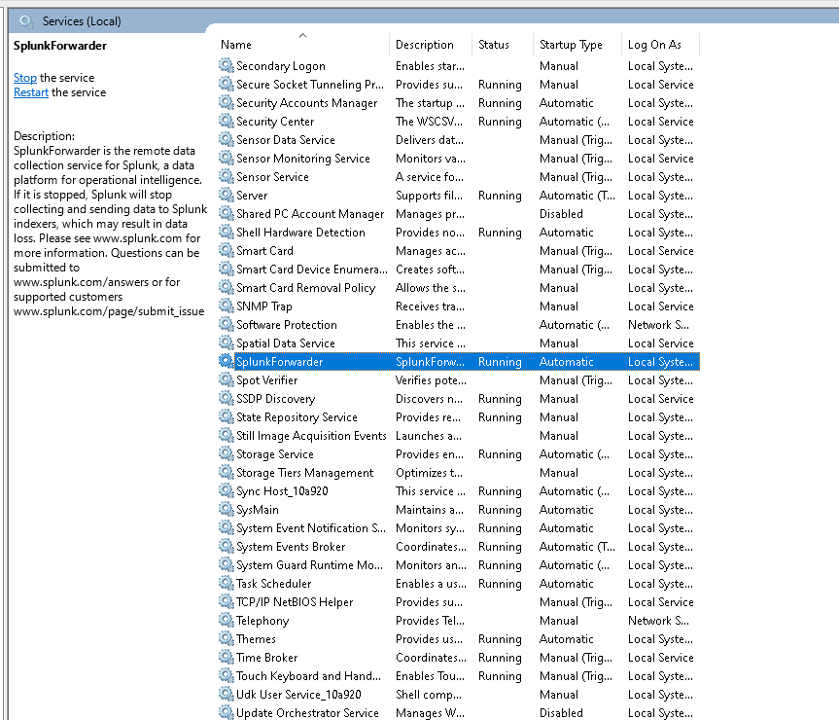

🔴 STEP 5 — ENABLE WINDOWS SECURITY LOG INPUT
File (manual GUI edit)
C:\Program Files\SplunkUniversalForwarder\etc\system\local\inputs.conf + outputs.conf

(create it) (save as not text file)

Content:
[WinEventLog://Security]
index = windows
disabled = 0

[WinEventLog://System]
index = windows
disabled = 0

[WinEventLog://Application]
index = windows
disabled = 0
Save file.

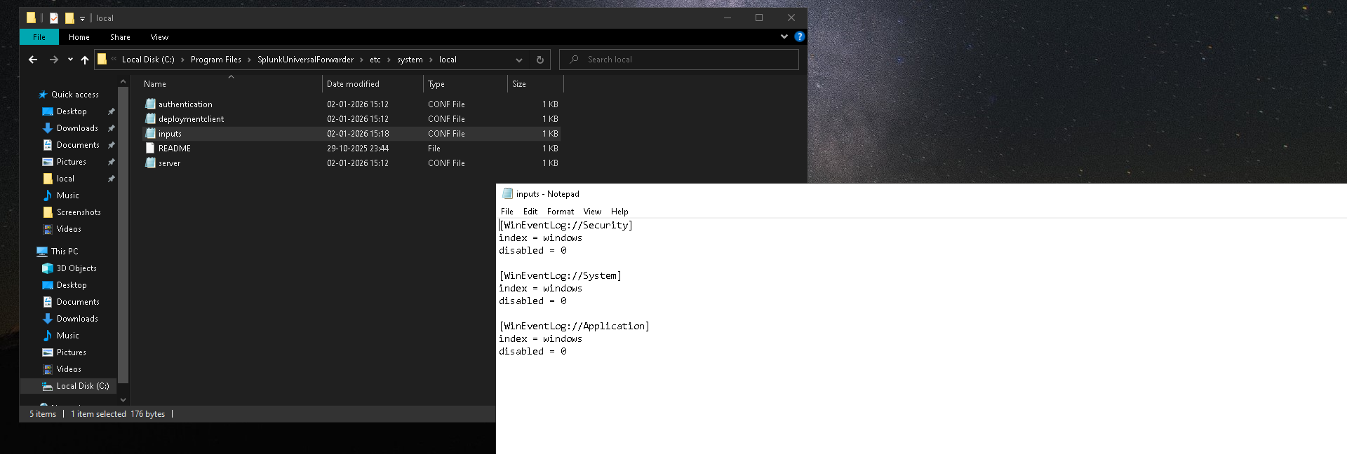

- For outputs: configure using the Splunk server IP (where the splunk enterprise installed), see the image below

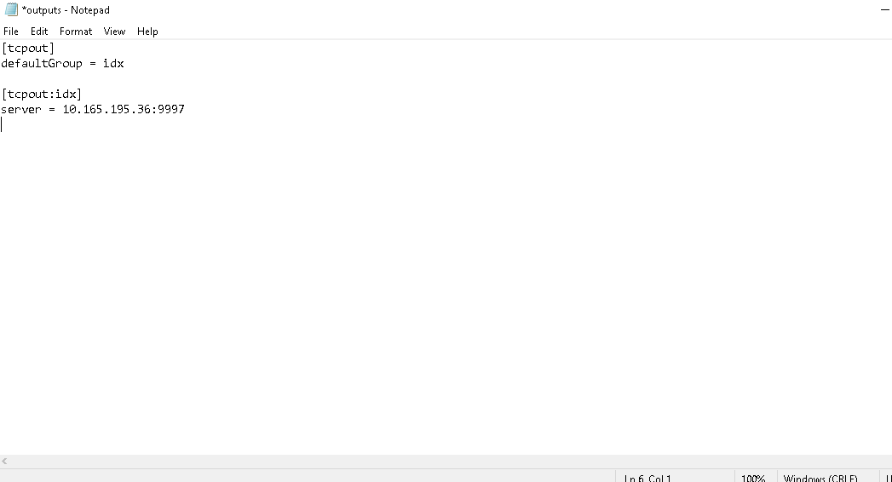

After saving both files Restart the SplunkForwarder service.

PART 5 — VALIDATION (WINDOWS PHASE 0)

🔴 STEP 6 — CONFIRM DATA ARRIVES IN SPLUNK
Search:
index=windows
Time: Last 24 hours
You must see:
- Events appearing
- sourcetype=WinEventLog:Security
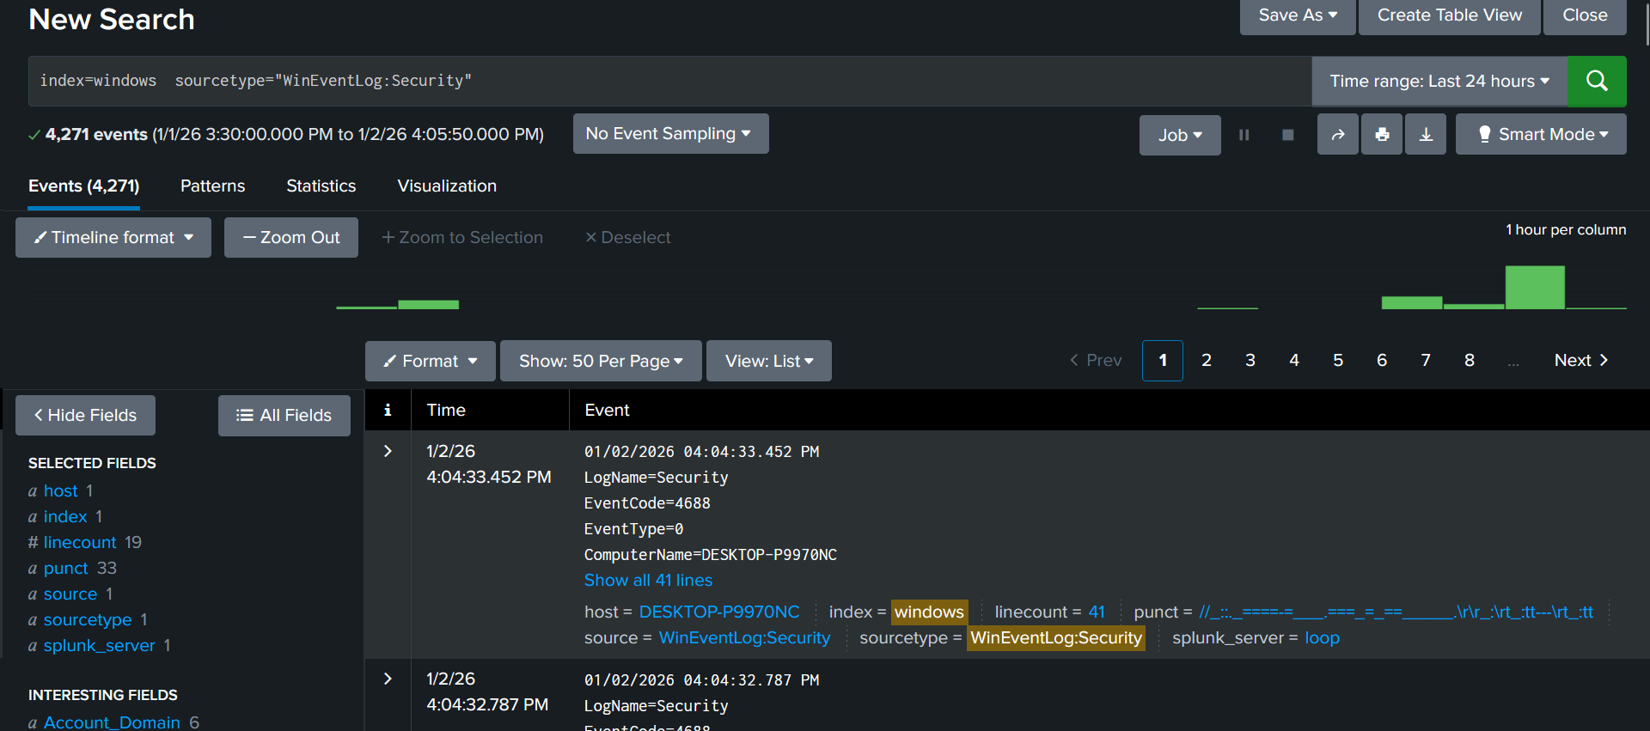

🔴 STEP 7 — VERIFY SOURCETYPE & EVENT BREAKING
Expand one event:
- Sourcetype must be WinEventLog: Security
- One Windows event = one Splunk event
Merged/split events = stop and fix.

🔴 STEP 8 — VERIFY TIMESTAMPS
Compare:
- Raw message time
- Splunk _time
Small delay = OK
Large mismatch = broken timelines.

🔴 STEP 9 — VERIFY FIELDS (EVIDENCE LAYER)
Confirm fields exist:
- EventCode
- ComputerName
- TargetUserName
- LogonType
- IpAddress (may be empty for local logons)
Missing fields = parsing problem.

🔴 STEP 🔟 CONFIRM INDEX ISOLATION
Run:
index=windows
and
index=linux
Confirm:
- Windows logs only in Windows
- Linux logs only in Linux

PART 6 — INTENTIONALLY EXCLUDED (AND WHY)
These are NOT missing — they are deferred on purpose:
- Sysmon → advanced endpoint telemetry
- PowerShell / Script Block logging → meaningful with AD & admin context
- Registry auditing → requires persistence knowledge
- Object access everywhere → meaningful with shared resources (AD)
- Credential validation deep audit → pure AD territory
Enabling these now would:
- Add noise before skill
- Break learning flow
- Create false confidence

